

**Kubernetes Object Overview:**

Let us now discuss kubernetes objects.

Earlier we used to call objects as a service. Later kubernetes emerged with other concepts with the name called services. Thus objects came into limelight under which services, workloads etc., are considered.

Objects means the creation of anything(such as network policy, configmaps. ingress, PV, workloads etc)on a kubernetes cluster. Likewise to deploy any applications on the kubernetes cluster we use workloads which are listed below. Every workload will create a pod and all pods will try to create a container.

**Approaches to deploy applications on kubernetes**

| **Objects** | **Workloads** |
| --- | --- |
| All Workloads | Pods |
| Service | Replication Controller / Replication Set |
| Configmaps/Secrets | Deployment |
| Ingress | Daemonset |
| Network Policy | Statefulset |
| PV, PVC & Storage class | Jobs and Cron Jobs |
| Many More |  |

**Pods Introduction:**

* Pod creates a logical layer to group one or more containers to have ***common network*** and ***shared storage***.
* Pod has a unique ip address assigned from –pod-network-cidr=10.244.0.0/16
* Since containers share the same network stack within the pod, containers in a pod will communicate on localhost or 127.0.0.1 (loopback interface) and also share the same namespace. But container communication outside the pod will be through the pod ip address.

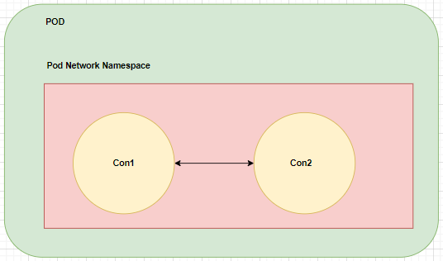

* In a case where data replication is needed among all the containers running inside the pod, we use a phenomenon called pod shared storage in order to share the same data across the containers.

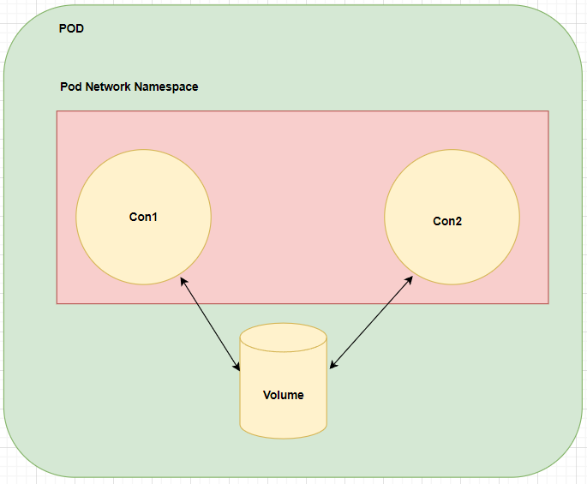

* As a best practice, containers in a pod are created dependent on one another which means running different applications across the containers is not preferrable.